## Project Design Phase-II

**Solution Requirements (Functional & Non-functional)**

|  |  |
| --- | --- |
| Date | 10 October 2022 |
| Team ID | PNT2022TMID33940 |
| Project Name | Plasma Donor Application |
| Maximum Marks |  |

|  |  |  |
| --- | --- | --- |
| **FR No.** | **Functional Requirement (Epic)** | **Sub Requirement (Story / Sub-Task)** |
| FR-1 | User Registration | Registration through Form Registration through Gmail  Registration through LinkedIn |
| FR-2 | User Confirmation | Confirmation via Email  Confirmation via OTP |
| FR-3 | Authentication | Authentication Authorization |
| FR-4 | Certification | Digital Certification |

### Non-functional Requirements:

Following are the non-functional requirements of the proposed solution.

|  |  |  |
| --- | --- | --- |
| **FR No.** | **Non-Functional Requirement** | **Description** |
| NFR-1 | **Usability** | Systematic Review Protocol |
| NFR-2 | **Security** | Authentication Authorization Encryption Logging  Application security testing |
| NFR-3 | **Reliability** | Robustness Security  Compliance |
| NFR-4 | **Performance** | Application performance monitoring (APM) |
| NFR-5 | **Availability** | Overall application uptime and downtime |
| NFR-6 | **Scalability** | Global scalability using IBM Cloud |

### Functional Requirements:

Following are the functional requirements of the proposed solution.

# FR-1: User Registration

## Registration through Form

The app will have registration function in various ways and systems. One of which will be through forms, this type of registration can be accomplished through offline physical form-based registration.

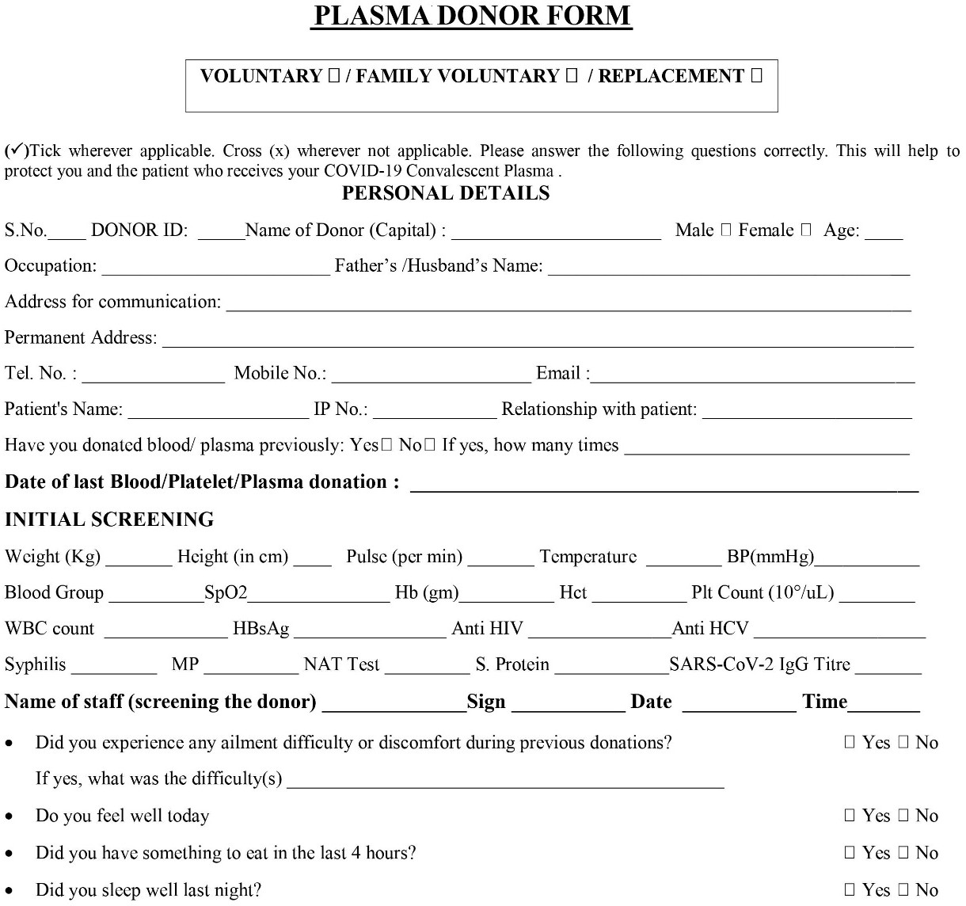

These types of forms are often seen in physical locations like the hospital or clinics that accept the plasma donation.

## Registration through Gmail

Gmail is the leading email service provider in the world, billions of users use Gmail for their daily purpose. This is a great way to get users to sign up for plasma donation. This can help users to be easily notified to help the process of plasma donation through email. All they need to do is sign up a form like so, to get registered.

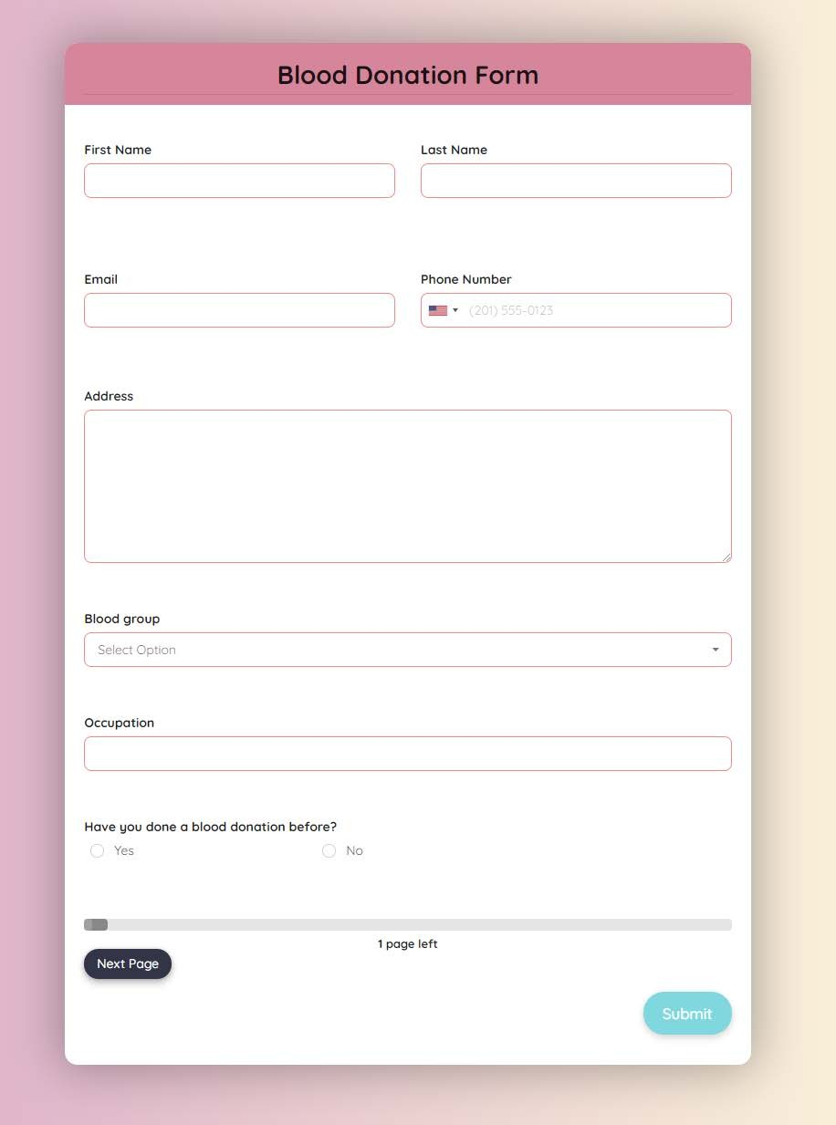

## Registration through LinkedIn

LinkedIn is a social media website for professionals, they can promote forms and other functions to get users to register for the program, they can then fill out a form and the concerned people can be notified through the platform in order get enrolled in this great virtue.

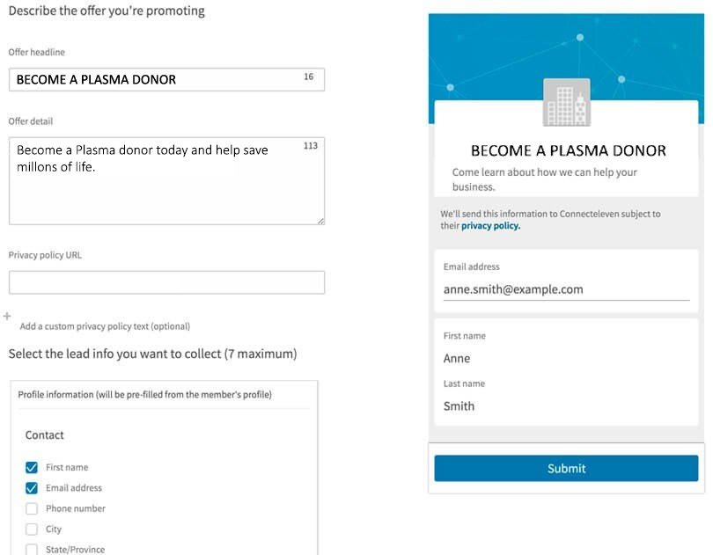

# FR-2: User Confirmation

## Confirmation via Email

After the registration users need to be notified through the help of email about their registration. The users can also be verified by the use of their personal emails so they can be contacted in future.

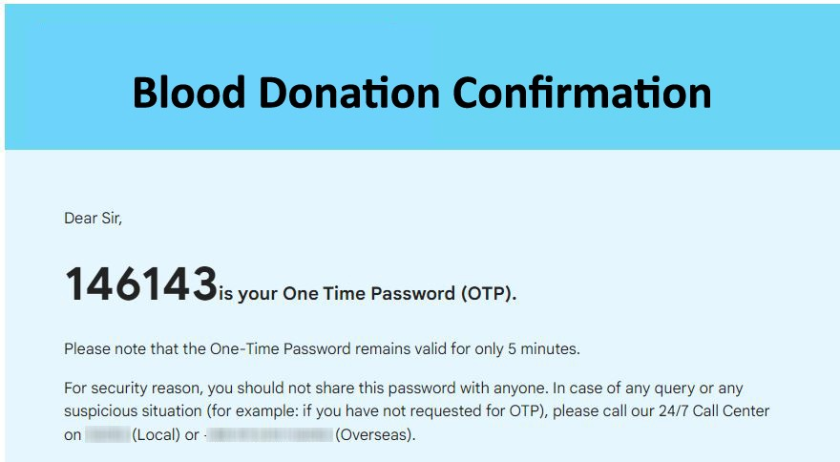

## Confirmation via OTP

The users can also register through their mobile number where they can be contacted in future. This verification will be done through an OTP sent to them via SMS.

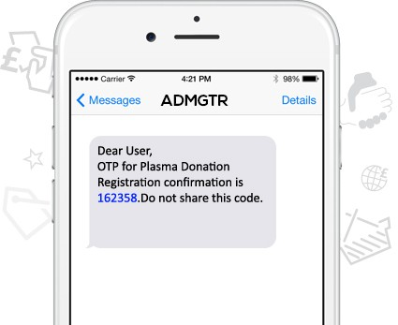

# FR-3 Authentication

Authentication is required for the donators as well as the receivers to ensure only the truly needful patients can request for the plasma, and there is no scams or frauds going on in order to endure the secure donation of plasma. For this purpose

* Only certified clinics can request donation
* The donors need to be health screened and verified
* The only communication request should be put through the secure connection

The following page should and will be known as the go to place for plasma donation and the authentication will be verified by the server.

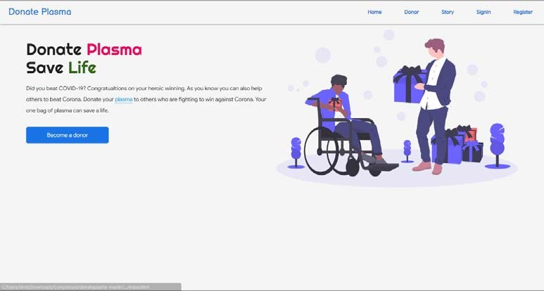

# FR-4: Certification

Upon successful completion of plasma donation, the donator will get a certification that certifies their contribution in saving lives donating plasma.

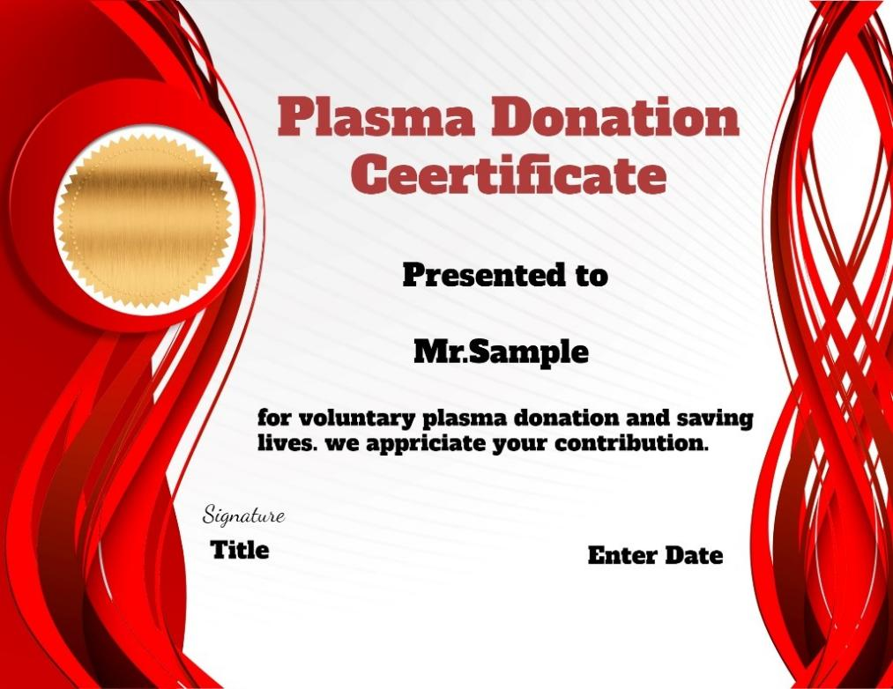

### Non-functional Requirements:

Following are the non-functional requirements of the proposed solution.

NFR-1 ***Usability***

To analyse the usability compliance of our plasma donation app. An analysis process based on a systematic review protocol is used to select free plasma donation apps. An assessment is conducted concerning the compliance of free plasma donation apps with Android, Blackberry, iOS and Windows usability guidelines. A total of 25 free apps have been selected from 188 plasma donation apps identified. Our prototype app secured seventh position among the 25 in terms of usability, user-friendliness and effectivity.

NFR-2 ***Security***

Security is important because our application is available over various networks and connected to the cloud, increasing vulnerabilities to security threats and breaches. For that reason, we have taken the following measures in our app.

**Authentication**: To ensure that only authorized users gain access to our app authentication procedures is used. This is accomplished by requiring the user to provide a user name and password when logging in to the application. We also have multi-factor authentication which requires more than one form of authentication the factors include something you know (a password), something you have (a mobile device), and something you are (a thumb print or facial recognition).

**Authorization**: After a user has been authenticated, the user needs be authorized to access and use the application to send requests. The system can validate that a user has permission to access the application by comparing the user’s identity with a list of authorized users. Authentication must happen before authorization so that the application matches only validated user credentials to the authorized donators and requestors.

**Encryption**: After a user has been authenticated and is using the application, encryption security measures can protect sensitive data from being seen or even used by a cybercriminal. In cloud-based applications like ours, where traffic containing sensitive data travels between the end user and the cloud, the traffic is encrypted to keep the data safe.

**Logging**: If there is a security breach in an application, or even a registered user has gone rogue logging can help identify who got access to the data and how. We keep application log files to provide a time-stamped record of which aspects of the application were accessed and by whom.

**Application security testing**: We test our app security regularly. A necessary process to ensure that all of these security controls work properly. We provide monetary remuneration to anyone who can breach our security and fix it as soon as possible

NFR-3 ***Reliability***

Reliability metrics are used in our plasma donation app to quantitatively expressed the reliability our software product. The option of which metric is to be used depends upon the type of system to which it applies & the requirements of the application domain. To ensure reliability we look for the following in our app

**Robustness**: Primary importance to the success of any application is the health, or robustness, of the application. If the application is unstable or crashing intermittently, it lacks robustness. We keep app stability in our top most priority to ensure a pleasant experience before putting it in a high availability environment.

**Security:** We have a state-of-the-art security system as discussed above.

**Compliance:** Application compliance enables us to define and control the type and version of our software a device can have installed. This enables us to control the type of software our users can run and minimize the potential of having unwanted pirated software or malware attack on our network.

NFR-4 ***Performance***

We use Application performance monitoring (APM) which is a process of managing our plasma donation software application to ensure its optimal performance by gauging key performance indicators like Apdex scores, throughputs, and response time as well as the overall user experience. This solution helps us analyse our application performance, gain a holistic view of how our application components connect and communicate with each other, and identify application performance issues before they impact real users.

NFR-5 ***Availability***

Application availability is a measure we use to evaluate whether our application is functioning properly and usable to meet the requirements of our users. Application availability is determined based on application-specific key performance indicators such as overall or timed application uptime and downtime, number of completed transactions, responsiveness, reliability, and other relevant metrics. Real or perceived application failures are also taken into account, such as consistent errors, timeouts, missing resources, and DNS lookup errors. We try to keep our downtime at the lowest because you never know when someone is in need of our services. We also notify about our system downtime in advance to deploy necessary maintenance and security measures.

NFR-6 ***Scalability***

The App uses IBM cloud as its primary server so it can be implemented around the globe effortlessly. Any device can connect to the app via mobile or web application from anywhere in the world. Geo location integration lets the app work in each and every specific area of the world Our databases can store and infinite number of records so apps scalability level is global.